
ANALYSIS OF DESIGN AND ALGORITHMS

Submitted by: Hemant Saini
Course : B.Tech CSE (DS)
Semester : IV
Roll No : 2401420051
Submitted To: Aarti Sangwan

- Understanding Algorithm Efficiency through Analysis, Recurrences, and Sorting
- TASK 1: Algorithm Growth Observation
- Constant Time {O(1)}:
CODE AND OUTPUT:
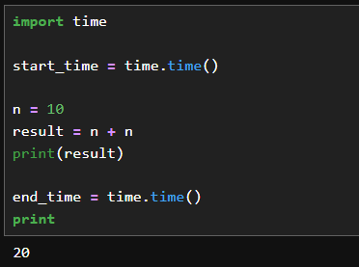

2.Linear Time {O(n)}:
CODE AND OUTPUT:
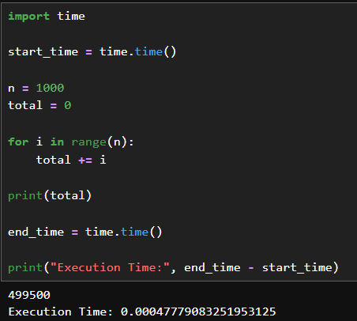

3.Quadratic Time{ O(n^2)}:
CODE AND OUTPUT:
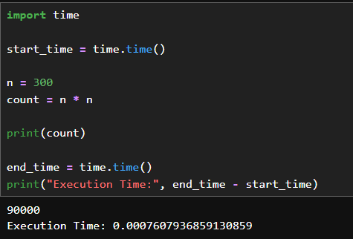

4.Logarithmic Time{ O(logn)}:
CODE AND OUTPUT:
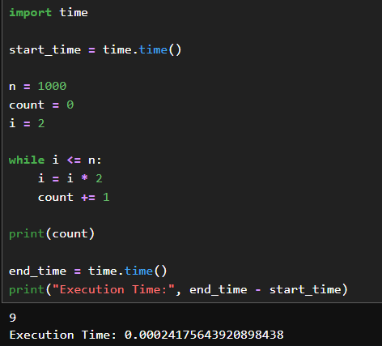

GRAPH OF INPUT SIZE VS EXCECUTION TIME:
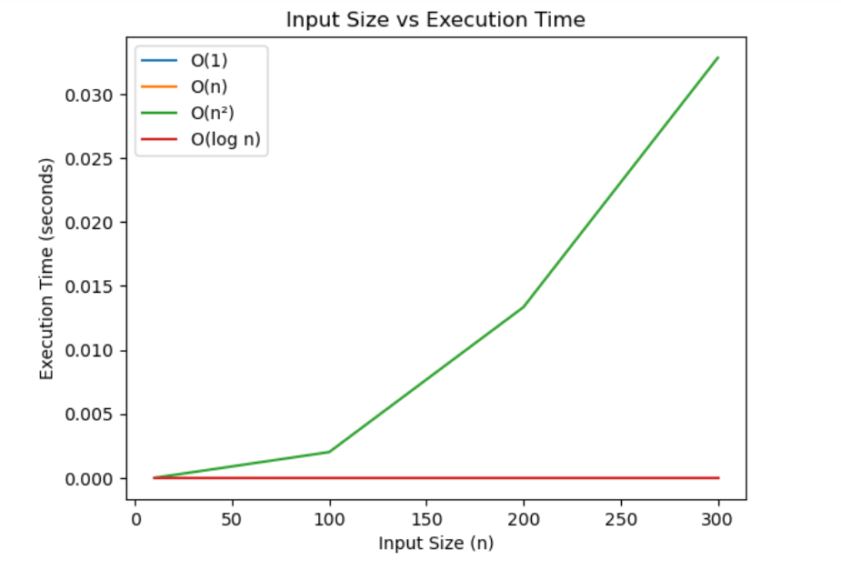
Observation:
- O(1) remains almost constant
- O(log n) increases slowly
- O(n) increases linearly
- O(n²) increases rapidly
Conclusion:
Execution time increases with input size depending on algorithm complexity.

TASK 2: Best, Average, and Worst Case Analysis
Linear Search:
- Best Case:
CODE AND OUTPUT:
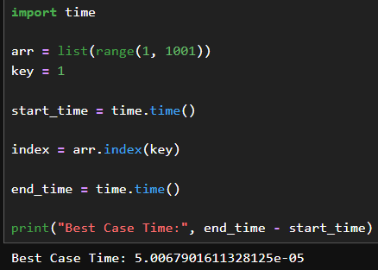

- Average Case:
CODE AND OUTPUT:
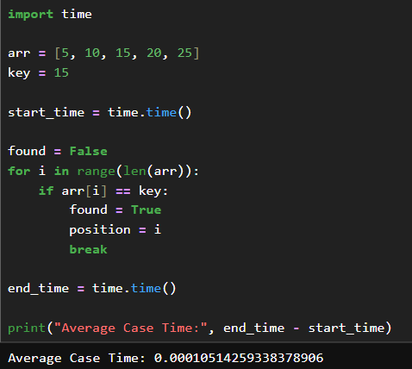

Worst Case:
CODE AND OUTPUT:
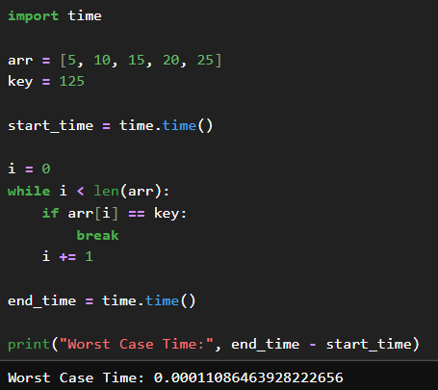

COMPARISION PLOT:
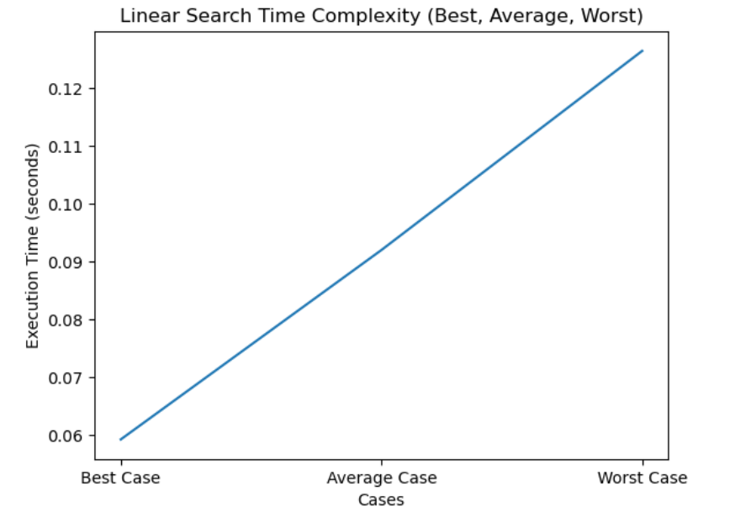
*The plot shows that worst case takes maximum time and best case takes minimum time for linear search.
TASK 3: Recursion and Recurrence Validation
- FACTORIAL:
CODE AND OUTPUT
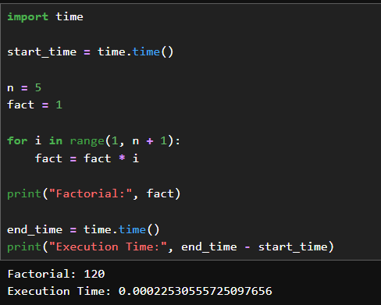

- FIBONACCI(RECURSIVE):
CODE AND OUTPUT:
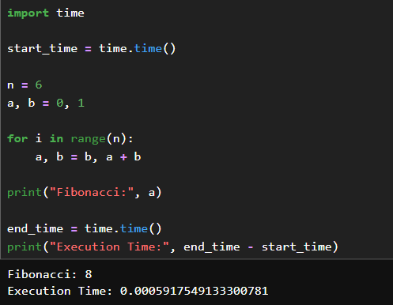

- FIBONACCI(ITERATIVE):
CODE AND OUTPUT:
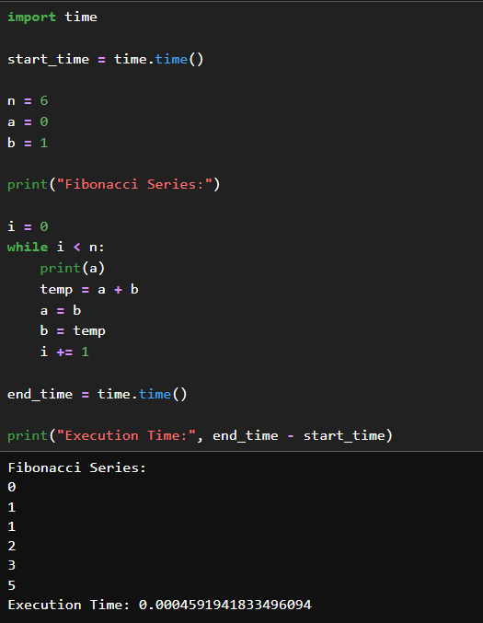
Observation:
Recursive Fibonacci takes more time compared to iterative approach.
Conclusion:
Recursion increases execution time due to repeated function calls.

TASK 4: SOLVING RECURRENCES THROUGH CODE

- T(n) = T(n/2) + n
CODE AND OUTPUT:
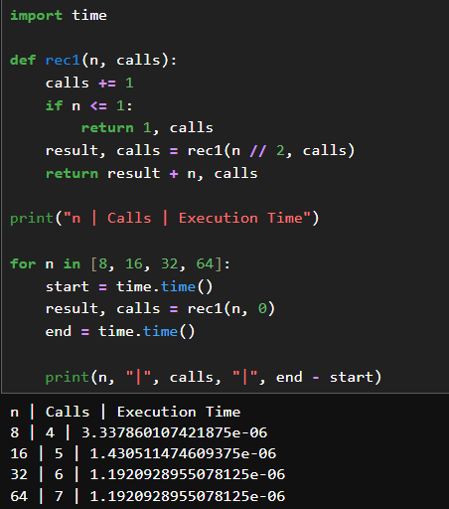

- T(n) = 2T(n/2) + n
CODE AND OUTPUT:
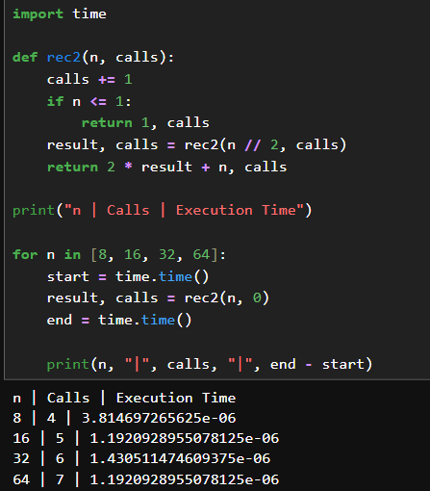

For T(n) = T(n/2) + n
- Number of recursive calls increases logarithmically
- Execution time grows linearly
- Asymptotic Complexity: O(n)
For T(n) = 2T(n/2) + n
- Number of recursive calls increases rapidly
- Execution time grows faster than linear
- Asymptotic Complexity: O(n log n)

